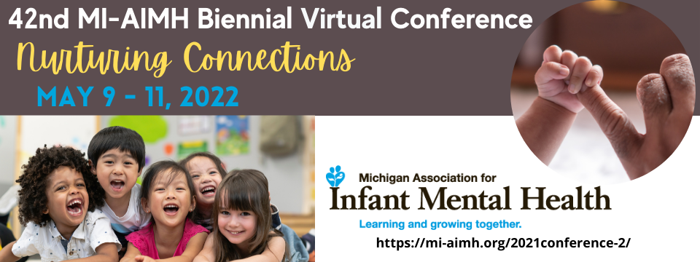

2022 Conference Student Posters – Instructions/Guidelines and Expectations

Student Posters
Student Posters are invited that address the multiple needs of infants, young children and their families within the context of their relationships and with a particular emphasis on families affected by poverty, structural inequities, and oppression. Student Posters are invited that highlight the application of infant and early childhood mental health principles in multiple disciplines such as social work, psychology, counseling, pediatric health professions, early childhood care and education, speech and language and child welfare.

Selection Criteria:
A limited number of poster presentation spaces are available. Submissions will be reviewed with attention to the following criteria:

1. Relevance to one or more of the areas of competency identified in the MI-AIMH Endorsement® materials that lead to culturally sensitive, relationship-based practice promoting infant and early childhood mental health (IECMH).
2. Clarity, organization, originality and innovation.
3. Relevance to the program theme: “Nurturing Connections"

Instructions:
Proposals must be submitted using the form supplied on the conference web site https://mi-aimh.org/2022-conference-student-posters/ by October 7, 2021. This form will allow you to enter your student poster information and submit in one step. You will be able to start the form, save your work and come back to complete prior to submission. Student Poster presenters are expected to register for the conference at student rates.

These are the chronological steps for submitting a conference student poster:

Step 1: Read through this document and determine if you would like to submit a poster
Step 2: Gather all of the required information that is needed to complete the Student
Poster Application Submission. All of the items are listed on pages 2-4.
Step 3: When you are ready, complete the online Full Conference Workshop Proposal
Submission – October 7, 2021
NOTE:
- The system will allow you to start entering information online and SAVE and CONTINUE
- To choose to Save and Continue, scroll down to the bottom of the form and you will see the link there.
- If you choose to Save and Continue – you will be prompted to copy a unique link – or – enter your email address and a link will be sent to you.
- This link will expire in 30 days from the day it is created
- If you do not return to the system and complete your submission information and process, after 30 days the information entered will automatically delete and the link will expire.
- It is recommended that only the Lead Author/Presenter use the link and enter information – you can share the link, but two people cannot enter information at the same time.

Terms of Presentation: The 2022 Biennial Conference will be a virtual event hosted through the Blue Sky. Hosting this event virtually brings a wonderful opportunity to welcome student poster presenters from outside of Michigan! MI-AIMH is encouraging students from all over to submit a Student poster application. Please note that the conference time will be the Eastern
Standard Time Zone. Posters selected will have access to the following support
for this virtual conference:
- Best practices and tips on student posters in a virtual conference
- Support through Blue Sky event managers and AV professionals
- Student poster presenters will be able to:

  - Have their student posters and information available on the platform for the entire conference
  - Include an image of your poster presentation available for attendees
  - Upload video presentation
  - Make handouts easily available for attendees
  - Share student authors contact information, bio and photos
  - Chat for Q&A with attendees
·
- Special D Events will work closely with students to collect student authors and poster information that will be loaded into the virtual platform. Students are not expected
to input information into the platform (that will be handled for you); however, they are expected to adhere to poster, video and/or handout submission deadlines as outlined by Special D Events.
- There is a maximum number of six authors allowed to present poster/video and/or chat for Q & A with attendees. Please note, either the primary or one of the subsequent presenters, as indicated on this form, must present the poster. No alternate presenter will be approved.
- Speakers must be ready to participate in a chat for Q & A session with attendees. The day/time will be determined soon.
- Poster presenters are expected to register for the conference at student rates (typically under $100). Poster selections will be made early December 2021.

Student Poster Requirements
Gather all of these items together PRIOR to starting your online application and submission.

1. Title of Poster
2. Abstract - Abstracts are allowed a maximum of 100 words and are listed in registration materials. This should provide participants with a clear idea of the focus, goals and intended audience.
3. Presenter Information
a. Workshop submissions are allowed to have a maximum of SIX presenters
b. A Lead Presenter needs to be identified for student posters - The Lead Presenter will be the main contact and responsible for communicating logistics, etc.
c. This information will be required from ALL presenters
i. Name, Credentials & Field of Study (M.A. in?)
ii. Endorsement® Type (enter NA if needed)
iii. University/College
iv. Number of years of experience on workshop topic
v. Email
vi. Mailing Address
vii. City, State, Zip Code
viii. Cell Number
4. Description - One-page description of your poster that includes the theoretical and/or empirical background of the poster presentation (e.g., attachment theory, trauma research, etc.). A description of the poster presentation will inform either clinical or applied practice or empirical research in the IMH field. Maximum # of 1,000 words.

For questions regarding Student Poster, please contact miaimh.conference@gmail.com

