Karol Wilson, LMSW, IMH-E®

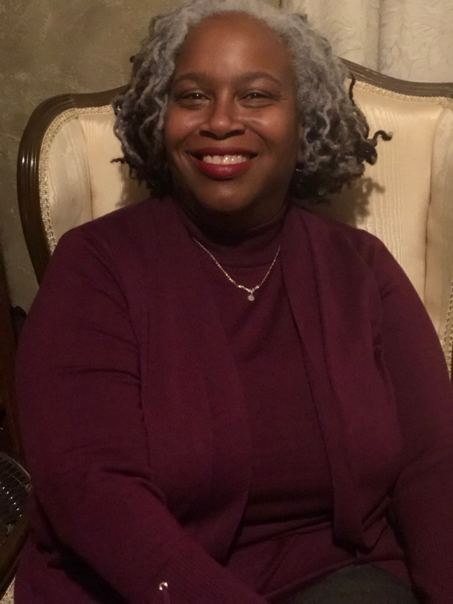

Karol Wilson’s experience in Infant Mental Health began in 1992 when she interned at Children’s Center in Detroit MI and later supervised Children’s Center’s Special Beginnings Infant Mental Health Program. Karol’s 20 plus years in the field includes administrative duties, group and individual reflective supervision and consultation. Karol has provided trainings on attachment, infant mental health, diversity and talking with parents about tackling challenging conversations. She has worked as an Infant Mental Health Specialist in Grand Rapids and later at St Joseph Mercy as an Intake Specialist in the Healthy Start. Program. Karol was one of the first Michigan Association of Infant Mental Health Diversity Fellows and the first African American to achieve endorsement as an Infant Mental Health Mentor. Additionally, Karol received the Selma Fraiberg Award at the 2019 MI-AIMH Biennial Conference.
Karol has co -authored an article in press for the Reflective Practice Journal titled. The importance of examining diversity in reflective supervision when working with young children and their families. She also co-authored an article that appeared in the Infant Mental Health Journal “Implementation of the PICCOLO in Infant Mental Health Practice: A Case Study and presented this case study in Edinburgh Scotland. Karol also co- wrote an Attachment and Child Development resource guide to illustrate secure and insecure attachments for Michigan State University Students. She has co- presented a poster demonstrating the Effectiveness of Infusing Infant Mental Health with additional services to support at risk families at the Zero to Three Conference in San Antonio Texas, and on Reflective Supervision for Supervisors in San Diego California. Karol has collaborated with Wayne State University and MIAIMH to co-present workshops in Prague and Italy.
Currently, Karol co- supervises the Infant Mental Health home visiting program, “Partnering with Parents at Starfish Family Services. She has served on the Metro Detroit Infant Mental Health board and the Racial Equity Committee at Starfish.

