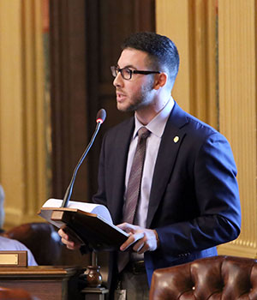

State Rep. Abdullah Hammoud is serving his first term in the Michigan House of Representatives, emerging as a strong voice for civil rights and a leading mind for health policy. He represents the 15th House District, comprised of his hometown city, Dearborn. As a proud son of immigrant parents, Hammoud has been unwavering in his commitment to Michigan and Dearborn for more than a decade. From volunteering at community cleanups with organizations like ACCESS to advocating to raise awareness for mental health conditions with the SAFE Substance Abuse Coalition, Hammoud has consistently given back to the community that fostered his growth and success.
Hammoud earned his bachelor’s in science from the University of Michigan-Dearborn and his master’s in public health from the University of Michigan-Ann Arbor. After working for three years as a health care consultant at the Center for Healthcare Research and Transformation, he felt a profound need to utilize his skills and knowledge to serve as a volunteer with the United Nations Relief and Work Agency in Jordan. During his months there, he led a successful initiative to reduce obesity among diabetic refugees throughout the Middle East.
In 2014, Hammoud was nominated and elected as the youngest board member for the Michigan League of Conservation Voters. For more than two years, he was on the forefront fighting to protect Michigan’s land, air and water by educating legislators and communities on the need for environmentally conscious policy. Recently, Hammoud returned to the University of Michigan in pursuit of a master’s in business administration at the Ross School of Business. Expanding his business acumen will help him craft economic policy to address the issue of income inequality, and to better support the hardworking middle class. In his spare time, he enjoys competing in obstacle courses, spending time with friends and family, and engaging in dialogue that fosters social benefit and growth.

