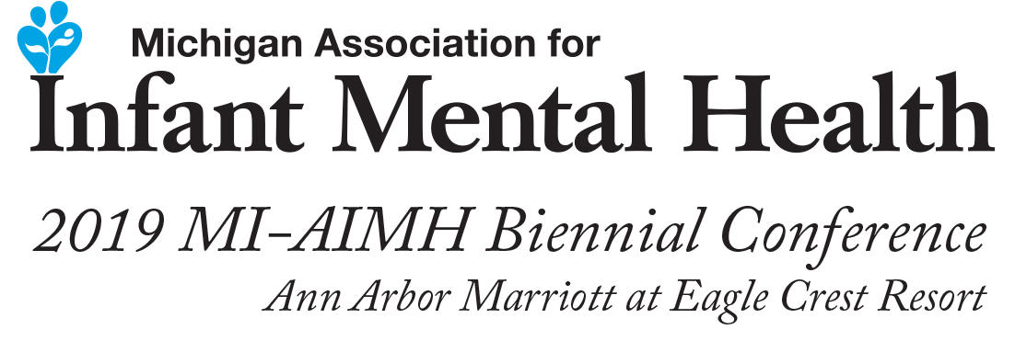

Kristie Brandt, NP, CNM, MSN, DNP

Dr. Brandt is an internationally known teacher, trainer, clinician, and consultant. She is Director of the Parent-Infant & Child Institute in Napa, CA that provides clinical services for children age 0-5, consultation for parents and providers, and professional training. She is also an Assistant Clinical Professor of Pediatrics V.F. at U.C. Davis School of Medicine, a Child Trauma Academy (CTA) Teaching Fellow with Dr. Bruce Perry in Houston, TX, and visiting faculty and a national trainer for the Brazelton Touchpoints Center (BTC) at Children’s Hospital Boston. She lectured for 15 years with Dr. T. Berry Brazelton on the National Seminar Series, and is a Brazelton Institute faculty trainer for the Newborn Behavioral Observation (NBO) System. She founded and now directs the Napa Infant-Parent Mental Health Fellowship in Napa, CA, a state and national award winning 15-month training program for professionals that had been training professionals since 2002 that is now affiliated with the University of California Davis Extension. She is the author of numerous articles, technical reports, and chapters, lead author of the book Infant & Early Childhood Mental Health: Core Concepts and Clinical Practice (American Psychiatric Publishing, 2014), and author of the book Facilitating the Reflective Process: An Introductory Workbook (2009). She was the Chief Public Health Manager in Napa County, CA and retired after 25 years of overseeing Maternal-Child Health and other public health services. She earned her Master’s and Doctorate at Case Western Reserve University, and is endorsed through the Michigan Association for Infant Mental Health, within the global Alliance for the Advancement of Infant Mental Health, as an Infant Mental Health Specialist & Clinical Mentor, and is endorsed by California’s Center for Infant-Family & Early Childhood Mental Health as a IFECMH Specialist and a Reflective Practice Mentor.

