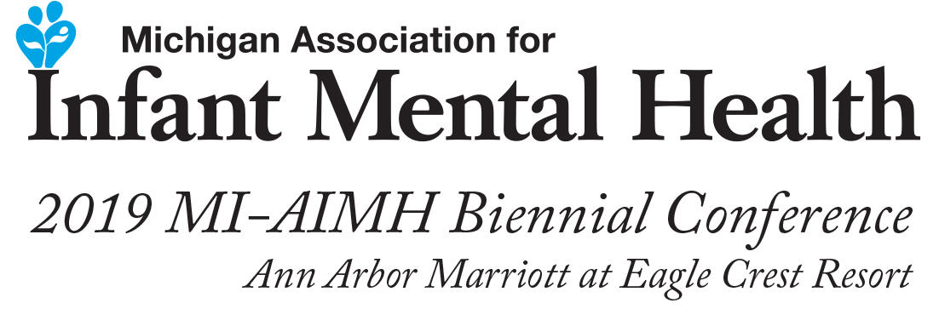

Deborah J. Weatherston, PhD, IMH-E®

Dr. Weatherston is the founding Executive Director for the Alliance for the Advancement of Infant Mental Health Inc. She earned her graduate degree from Wayne State University where she co-developed and directed the Graduate Certificate in Infant Mental Health at Wayne State University in Detroit, MI from 1988-2002. She then became the Executive Director of the Michigan Association of Infant Mental Health (2002-2016). She has written extensively about infant mental health principles and practices, and most recently, about reflective supervision as a cornerstone for effective work with infants, very young children and families.

