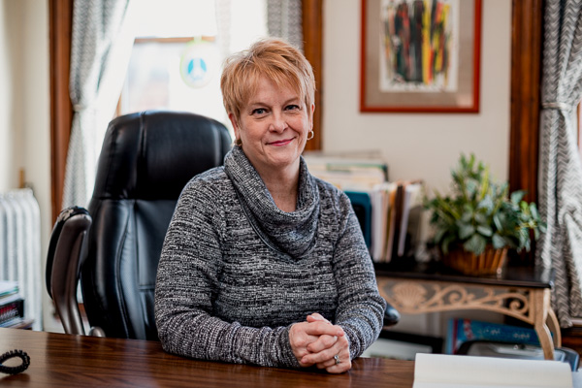

Deborah Drennan, CEO Freedom House – a Detroit-based nonprofit that provides services for political refugees

Drennan, program director for the agency since 2006, had served as interim director, succeeding Pegg Roberts who resigned for personal reasons in January 2009, said Pamela Marcil, vice chair of Freedom House and director of public relations for the Detroit Institute of Arts.
Drennan has more than 30 years’ nonprofit experience.
Prior to joining Freedom House in 2006, she was coordinator of intake and outreach services at Women ARISE and transitional housing program director and community relations/intake coordinator at the Coalition on Temporary Shelter.
Freedom House was founded in 1983 as a temporary shelter for those seeking legal asylum in the U.S. from political persecution in other countries.

