Driving Directions and Parking
Merrill Palmer Skillman Institute

The Merrill Palmer Skillman Institute is located at 71 East Ferry Ave, Detroit, MI 48202.

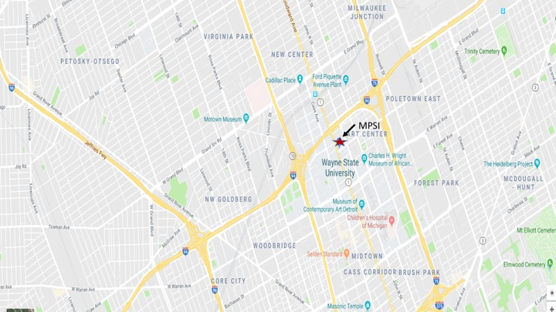

Parking:

There are several parking options. There is paid parking in the lot behind the Merrill Palmer Skillman Institute. The entrance is off John R between Palmer and Ferry on the right (west) side of John R. There is an $8 fee per entry (credit card swipe at entry and exit). Free street parking is limited, but available on Hendrie, Palmer and Ferry between John R and Beaubien and on John R between Hendrie and Ferry.

